48
STUMP LAKE

HABITAT REHABILITATION AND ENHANCEMENT PROJECT

Pool 26
Illinois River Miles 7.2 – 12.7

Jersey County, Illinois
St. Louis District

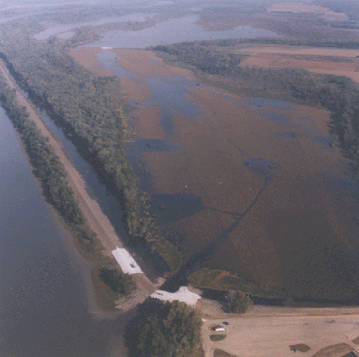

RESOURCE PROBLEM:

Sedimentation has resulted in a direct loss of wetland habitat for both waterfowl and fish. In addition, the lack of stable water levels has been deleterious to aquatic production.
PROJECT FEATURES:

- Construct a low sediment deflection levee, 5.5 miles long, paralleling the Illinois River shoreline and the perimeter of the WMA to reduce siltation from frequent floods and to improve wetland unit water control;

- Construct seven low-level interior levees around the perimeters of the four main wetland compartments to allow effective water-level management; and

- Install sluice gates and stoplog structures to control watering/dewatering of the four wetland compartments.

PROJECT OUTPUTS:

Dredging Long Lake and the upper portion of Deep Lake will improve water delivery and facilitate fish movement, spawning, and rearing. A reversible pumping system will be constructed on the Illinois River to allow flooding or draining of the wetland compartments.

FINANCIAL DATA:

General design costs were $521,000, and construction costs are estimated at $5,322,000. Annual costs for operation, maintenance, and repair are estimated at $33,700 and will be the responsibility of the non-Federal sponsor, the Illinois Department of Natural Resources.

STATUS:

The project was approved for construction in October 1992. The project has been subdivided into three items for construction: (1) the reverside levee, (2) interior levees and miscellaneous water control structures, and (3) the pump station. Completion of construction for all three items is scheduled for March 1998.

